Homework

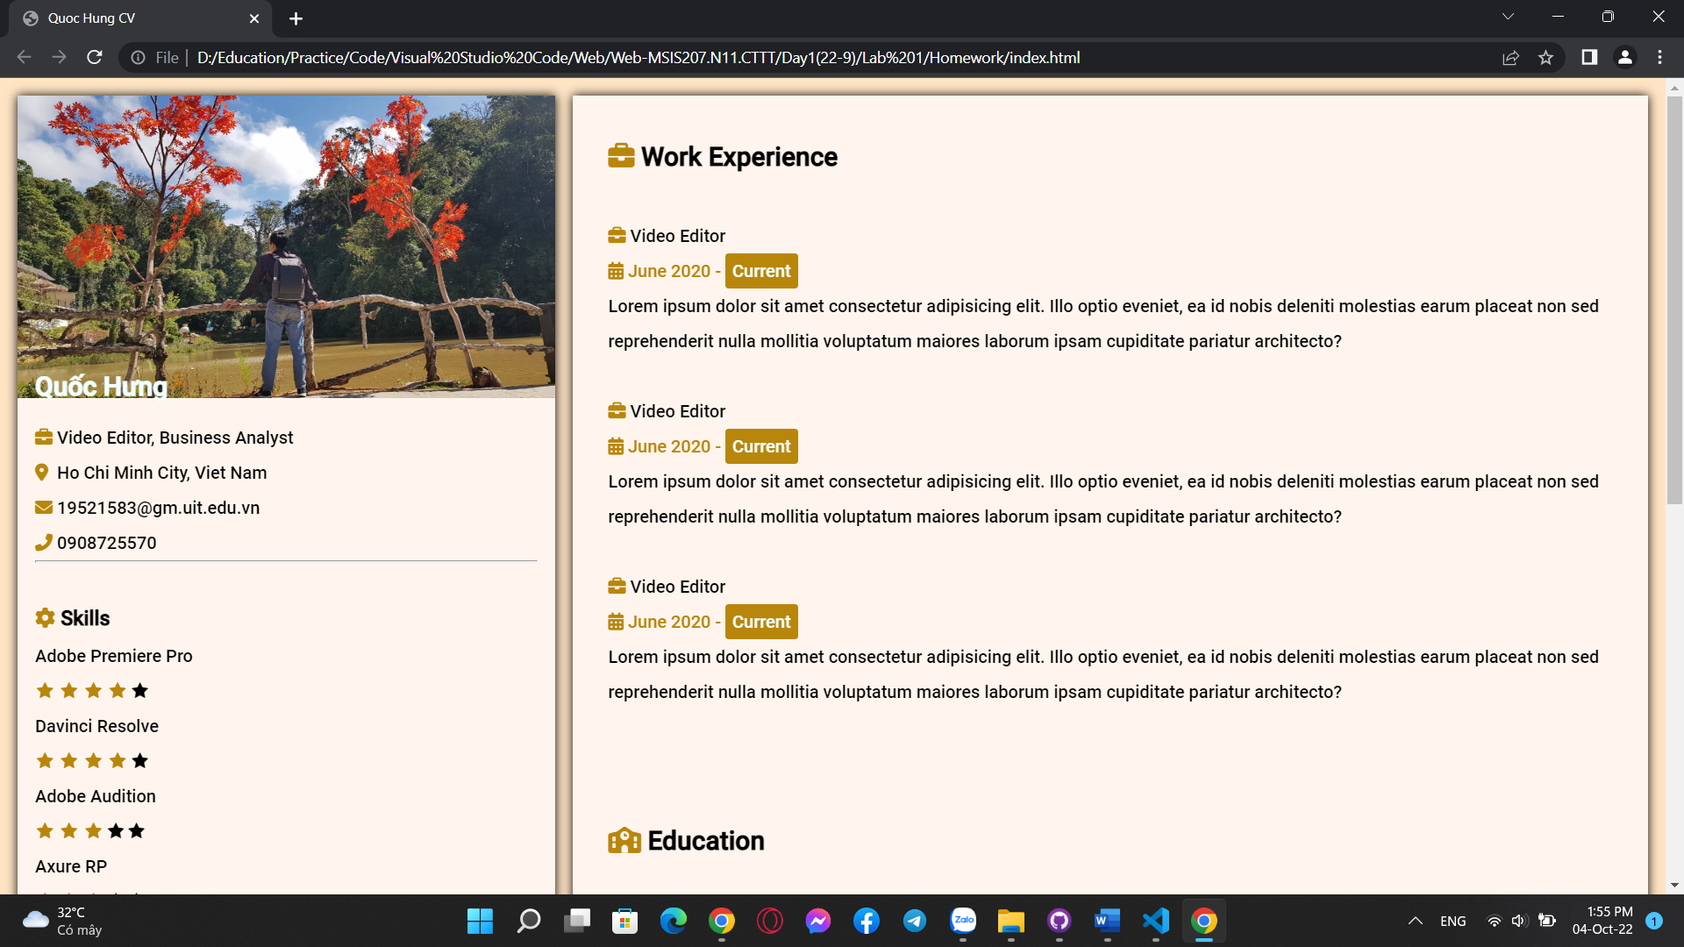

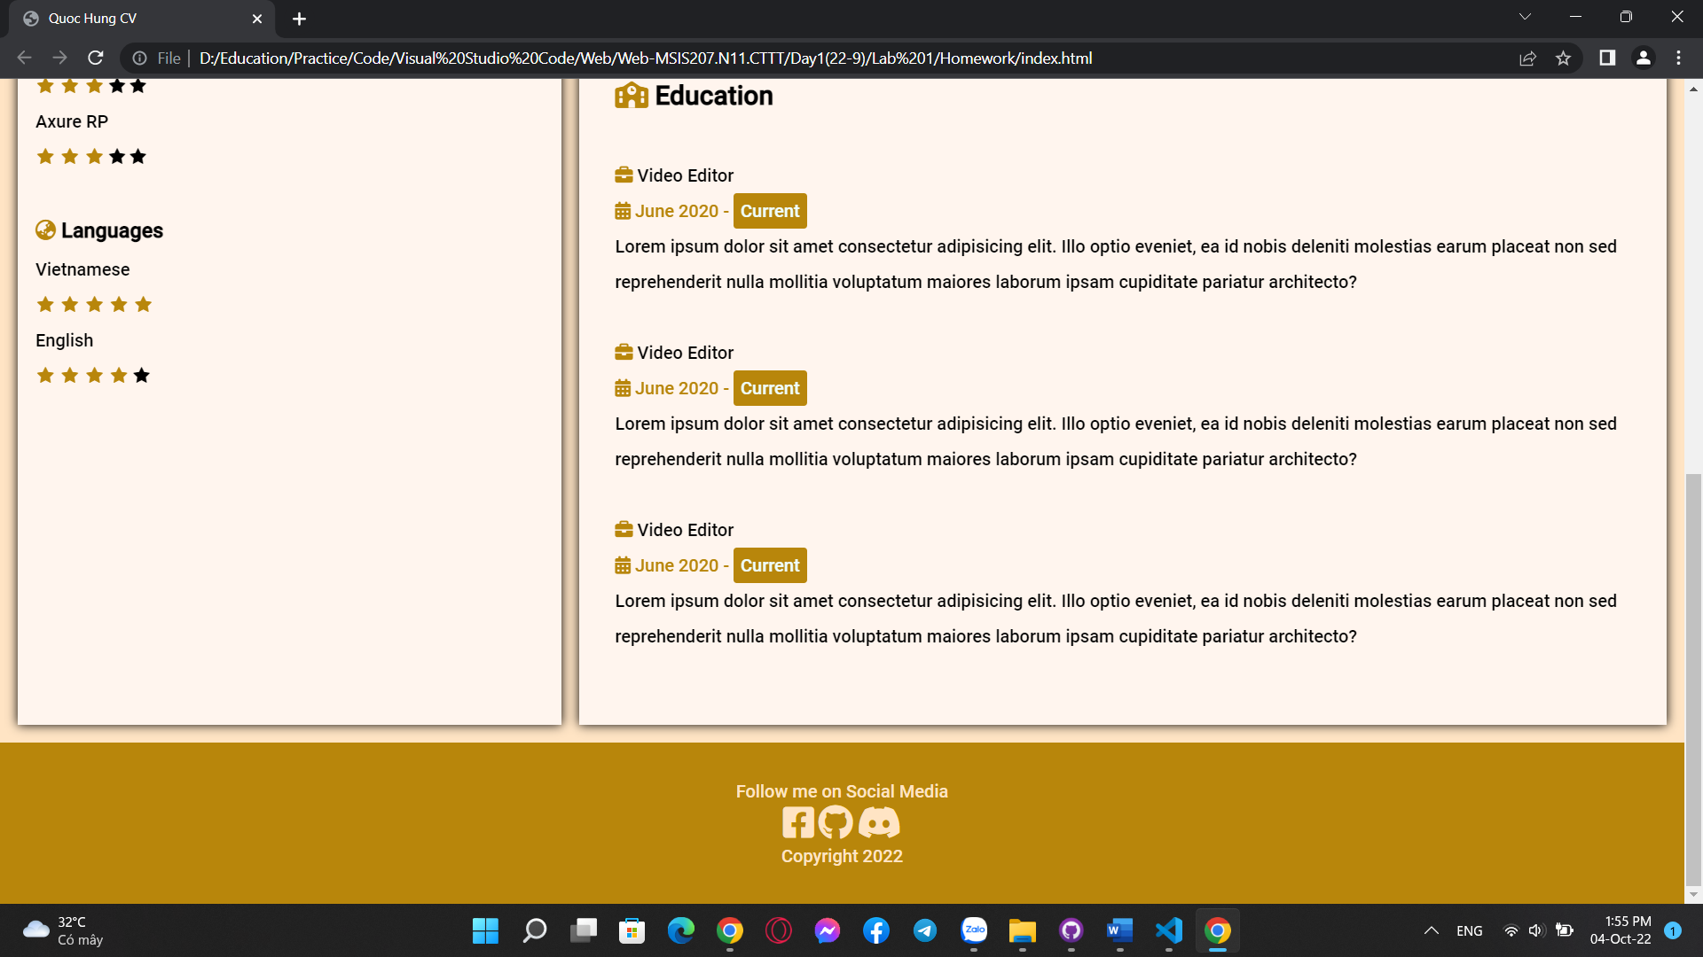

Link Github: https://github.com/tangquochung/Web-MSIS207.N11.CTTT/tree/main/Day1(22-9)/Lab%201